

Quick Installation Guide for Display-to-Go

These instructions are for installing the Display-to-Go and other support drivers on:
- Windows 98

- Notebooks with CardBus support

- Important Note: Multi-monitor capable display driver for the built-in (primary) VGA. Most VGA drivers that were shipped with Win98 Gold in August 1998 are not Multi-Monitor capable. Installing Display-to-Go on a system that does not support a second display adapter may result in malfunction or system crash. Updated drivers are available for most VGA devices on the Portable System Vendor or the VGA Chip Vendor’s web site.

Steps to INSTALL the Display-to-Go Driver

- Update the Primary Display Driver to the latest version.

- Ensure the Display-to-Go driver is accessible to the system. It can be on a floppy or a flash card or on a network drive.

- Insert the Display-to-Go card into one of the PCMCIA sockets. Do not connect the Monitor at this point. Windows will display a message “New Hardware Found” then a dialog box “Add New Hardware Wizard”, “PCI-VGA Compatible Display Adapter” is displayed.

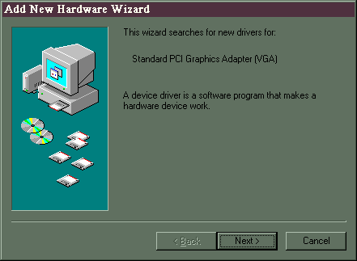

- Click “Next” Make sure “Search for the best driver for your device.” Is checked

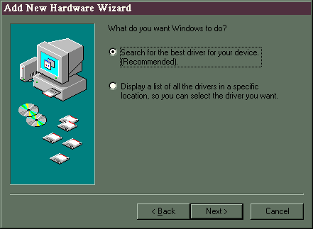

- Click “Next” then make sure that “Floppy disk drives” is checked

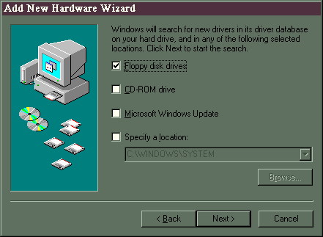

- Click “Next” Make sure “The updated driver” is checked.

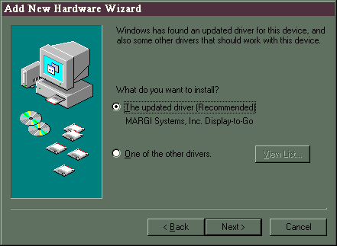

- Click “Next”.

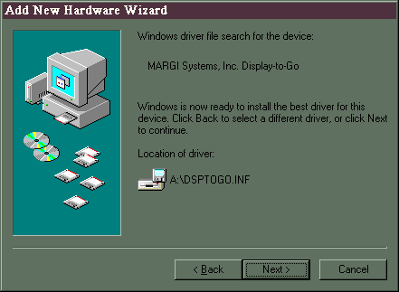

- Click “Next” The appropriate drivers will now be installed.

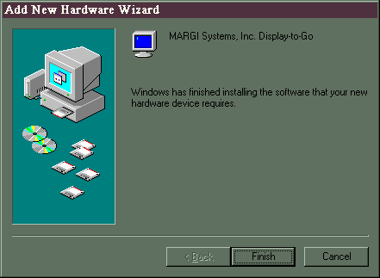

- Click “Finish” There will be a dialog box that detects unknown monitor. This is normal
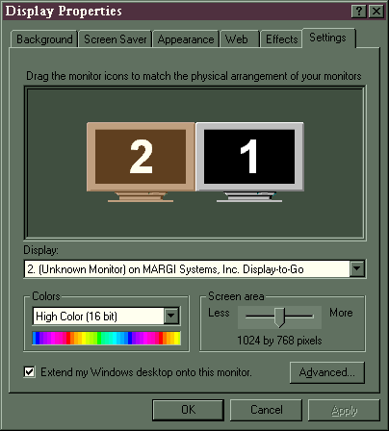
- From the Control Panel's Display Properties dialog box click Settings and enable the second monitor by clicking on it (typically it is the monitor with the label 2).

- Plug in the Monitor cable. The “Display-to-Go Monitor Detected” should be displayed. Click OK.

- The second Monitor should now display the Windows desktop.

Steps to UNINSTALL the Display-to-Go Driver

- Left click on the Display-to-Go icon on the Windows Taskbar.

- Click on “Uninstall”

- Follow the on-line instructions.

Usage

The Installation procedure above installs the Display-to-Go driver and an applet that resides as an icon in the SysTray (bottom right corner of the display). Double-click (with the left button) on the Display-to-Go icon to display the Applet Dialog Box. Right click on the icon to display a popup menu.

Display-to-Go SysTray Popup Menu

Open

This menu item displays the Display-to-Go applet Dialog Box.

Move Taskbar to Monitor #2/Move Taskbar to Primary Display

This menu item moves the Taskbar to the next display (typically monitor #2 – Display-to-Go screen) or back to the Primary Display. Moving the Taskbar using this menu item ensures that applications that are not multi-monitor aware will automatically launch on the display where the Taskbar resides. Moving the Taskbar manually by dragging it to another display will not force applications that are not multi-monitor aware to automatically load in that display.

Help

This menu item displays the on-line help.

Disable

This menu item disables the Display-to-Go PC Card so it can be removed from the system.

Exit

Exit the Display-to-Go applet.

Display-to-Go Applet Options

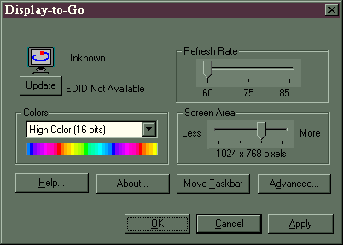

Refresh Rate, Screen Area & Colors

These options provide control over the display mode. The usage of these controls is limited by the connected monitor’s capabilities. If, for instance, the Screen Area control will only allow 1024x768 it is because this is the only mode the monitor supports. These controls are automatically set when a new monitor is detected.

OK, Cancel & Apply Buttons

These buttons behave like any other standard Windows driver.

OK

Closes the dialog box and saves any changes you have made.

Cancel

Closes the dialog box without saving any changes you have made.

Apply

Saves all the changes you have made without closing the dialog box.

Update (EDID)

Newer monitors have Extended Display Identification Data (EDID) that the software uses to identify the monitor and to adjust the Display To Go card settings. Clicking the Update button will read the EDID information that is programmed in the monitor.

Advanced...

This version of the applet has some controls in the Advanced options dialog box.

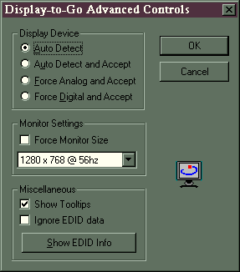

Auto Detect and Auto Detect and Accept

When a new monitor is detected, a dialog box appears that allows the user to 'Accept' or 'Modify' the default settings. If you click 'Modify', the main dialog box will open and you can adjust settings as necessary. If you click 'Accept', the display will be initialized with your last used settings, or with the program defaults. If you often use the same monitors, you can choose 'Auto Detect and Accept' in the Advanced Controls dialog box. At startup, the default display settings will be used without having to click the 'Accept' button, so that the computer will continue to start. Additionally, you can always adjust settings at any time by clicking on the Display-to-Go icon on the taskbar to open the main dialog box.

Force Analog/Digital and Ignore EDID

Newer monitors have Extended Display Identification Data (EDID) that the software uses to identify the monitor and to adjust the Display-To Go card settings. In some cases, the chosen settings are not optimal for your purposes. You can stop the software from using the EDID by clicking on 'Ignore EDID' on the Advanced Controls dialog box. The resolution, refresh rate and color depth will then be set from the settings on the main Display To Go dialog box. You can also force the settings to be Analog display or Digital display, if the software is not detecting the monitor type correctly.

Warning! These settings can also cause Display To Go to stop working because the software no longer auto detects the monitor type and settings. If you are having problems with your Display To Go card, make sure these Advanced Control options have not been accidentally checked.

© 1998-1999 MARGI Systems, Inc. All Rights Reserved. Display-to-Go™ is a registered trademark of MARGI Systems, Inc.

