Trouble shooter - contents
Trouble shooter - contents 1
Check hardware and software before installation 3
Notebooks (laptops) 3
OS version 3
The C - Pen 3
The C-Pen will not turn on 3
Read text 4
The Battery 4
Open files 4
Installation problems 5
Windows 98 5
Laptops: the correct built-in IR COM-port 5
IR communication: Normal behavior 6
IR communication: General problems 7
Distance from the IR port 7
The Infrared Monitor 7
The Status tab 8
The Options tab 8
The Preference tab 8
COM ports 9
The C-Pen is found by the IR Monitor but connection will not establish 9
Correct files 10
Windows 98 10
Windows NT 11
The C-Pen is not found by the Infrared Monitor 11
Wrong IR adapter installed 11
Windows 98 11
Windows NT 12
Conflicts with other hardware 12
Interference from other equipment 13
IR communication: On Notebooks (laptops) 13
Check the Generic IR Serial Port (COM) 13
Disabled Generic IR Serial Port (COM) 14
A red cross or an exclamation mark on the Generic IR Serial Port (COM) 14
Activate the IR port in BIOS Setup 14
Only one COM port on the laptop 15
Error messages 15
Error 5 15
Error 45 16
Error 54 16
No contact – Windows 9x 17
No Infrared icon in the Control Panel 17
Other Windows programs stop working 17
Uninstall and re-install IR drivers 17
Windows 95 18
Windows 98 18
Windows NT 18
Uninstall and re-install the C-Pen 18
Information: IR adapters 19
Windows 95 19
Windows 98 19
Windows NT 20
Adapters for stationary computers under Windows NT 20
Built-in adapters for laptops under Windows NT 20
Information: manufacturer policy 20
Built-in infrared COM port 20
Active or disabled IR eye as default 21
Information: Support addresses 21

Check hardware and software before installation
Please make sure you know which computer model you have and the manufacturers name. Is it a PC, Notebook (laptop) or desktop? What kind of processor, Intel, AMD or Cyrix? Sometimes laptops, AMD and Cyrix can cause trouble.

Notebooks (laptops)
Your laptop must have an infrared window a so-called IR-eye, otherwise you have to buy an IR adapter. The IR-eye is a black or red glossy square about 0,5 cm by 1 cm on the back or on the side of the laptop.

The built-in IR port has to be enabled otherwise it will be impossible to install the IR communication correctly. To check the IR port, please read the chapter Check the Generic IR Serial Port (COM. Further information for laptops is found in the chapter IR communication: On Notebooks (laptops).

OS version
Please make sure which OS version you have. The requirement is Windows 9x, Windows NT 4.0 or Windows 2000. No support for Windows 3.x, Windows NT 3.5x or older. No supports for other operating systems like Macintosh, Unix or Linux. No support for Windows CE or other Palmtop OS. To find which OS version you have:
- Choose Settings in the Start menu (in the lower left corner on the screen) and then select the Control Panel.
- Double-click the System icon and select the General tab.
- Check the OS version number.

The C - Pen

The C-Pen will not turn on
- Does the C-Pen have power supply? Read the chapter The Battery.
- The On/Off button must be held for one or two seconds until the display is lit. Do you press hard enough?
- Remove the battery and/or the power adapter plug; wait for about 10 seconds. Put the battery/power adapter plug back and retry to start the C-Pen.

Read text
- The correct reading technique gives optimal images of the original text and the image quality is crucial to get the best result. Please follow the instructions in the manual, quick start or Demo on the C-Pen software CD.
- Correct angle to the surface. The C-Pen’s nose opening should be parallel with and touch the surface. Move the C-Pen smoothly and not to fast. Place the C-Pen on the first character you want to read and then press the trigger and keep it pressed while reading.
- Correct settings for language and text quality. Try with different Text qualities but please note that the C-Pen can not read red or very light text.
- If the C-Pen reads badly, it may help to calibrate it. Read the user guide for information about how to calibrate the C-Pen.
- Is the front light lit when you press the trigger? Can you see the red light? If not, please contact your local retailer. If your local retailer is not available, contact the support department at C Technologies.

The Battery
If the battery has a low power level the C-Pen can automatically turn off or even get internal error, but it is not damaged. Check the power indicator every now and then and if the level is low, the C-Pen Original (C-Pen 1) should be charged. In case of a C-Pen 200, replace the batteries and keep in mind that re-chargeable batteries might work worse than common ones. It takes about 12 – 15 hours to charge the C-Pen original with the power adapter.

If the C-Pen crashes an error message appear, ‘Internal error, check battery’, and then the C-Pen restarts. However, all unsaved information will be lost. Similarly, information can be lost if the battery or power is removed before a text is saved. Always use the On/Off button to turn the C-Pen off.

Open files
There is a limitation in the C-Pen’s text editor. If the memory is getting full there might be difficulties to open large files. At the moment it is impossible to open files larger than 100 kilobytes.

It is possible to upgrade the C-Pen software using the infrared communication. Files will be available on www.cpen.com and instructions will be included when downloading.

Installation problems
If the installation program locks it self before the installation is done it probably depends on other program disrupting the installation. Close all programs and try again. If the problem remains, restart the computer and start the installation program prior to any other program.

Windows 98
First check that the right IR adapter and COM port are selected. It is possible to check and change the values, read the chapters The Infrared Monitor, COM ports and Wrong IR adapter installed.

Problems may occur if an old version of the IR support is installed in Windows 98. The original files used by Windows during installation of infrared devices may be overwritten. If you can not install the IR driver with help from the Read me file, the old files are probably the reason. For further information, please read the chapter Correct files.

Laptops: the correct built-in IR COM-port
The Add Infrared Device Wizard suggests several alternatives of COM-ports to which your built-in infrared port can be connected. If you use a Notebook (laptop) it is very important to select the correct alternative and that is the Generic IR serial Port (COMx).

Windows 95 connects the built-in infrared port on your laptop (the physical IR-port) to different COM-ports, depending on:
- The laptop manufacturer. Each manufacturer use different ports as physical IR port.
- Windows and Plug and Play.
- The number of hardware devices already installed on your laptop. Every time a new device is installed Plug and Play assigns it an available COM port.
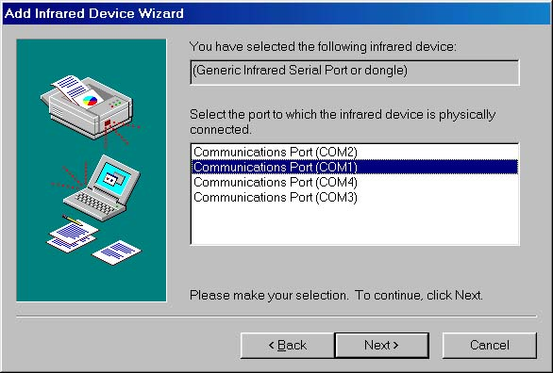
Figure 1 Select the correct COM port.

The default COM port for the physical IR port is set and altered in the Setup, and not in the window Add Infrared Device Wizard, Figure 1. For further information about the Setup, please read the chapter Activate the IR port in BIOS Setup.

IR communication: Normal behavior
Normally the dialog box in figure 1 shall pop up when double-clicking My C-Pen.
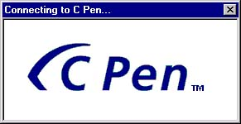
Figure 2 Connect window.

If contact is established between the C-Pen and the host computer, the contents of the C-Pen are displayed in an Explorer window, figure 2.

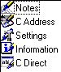
Figure 3 The contents of the C-Pen

IR communication: General problems
If there are problems, first of all try to restart the computer.

If contact is not established, normally an error message box appears. If no dialog boxes are displayed there is an error in the C-Pen Windows software installation and probably it is a .dll (dynamic link library) file missing. Try to reboot and re-install the C-Pen Windows software. Furthermore, observe the C-Pen’s display because if connection is established there should be a small icon to the very left next to the power level indicator. The icon looks something like |:::|. If a C-Pen 1 is used please watch the On/Off button since it should blink red if communication is established with the host computer, otherwise it is green.

If Windows 9x is used, please make sure that the Infrared Monitor is on and not disabled.

Distance from the IR port
Make sure the C-Pen is not too far away or too close to the PC’s IR port, replace or redirect the C-Pen and also try different angles between the devices. The ideal distance should be 10-20 cm.

The Infrared Monitor
The Infrared Monitor sends out an infrared beam every few seconds, searching for active IR devices. If it finds active devices, a symbol is displayed in the monitor window as long as the communication is not broken. In Windows 9x the Infrared Monitor can be used to troubleshoot the communication.

To open the Infrared Monitor window:
- Open the Control Panel (in the Start menu in the lower left corner of the screen).
- Double-click the Infrared icon.
Alternatively, if there is an infrared icon in the system tray (in the lower right corner of the screen) double-click it to activate the Infrared Monitor.

When the Infrared Monitor is on the screen, direct the C-Pen’s IR port towards the PC’s IR-port. In a couple of seconds, the C-Pen should appear in the monitor, according to Figure 4. If you want to change the COM port or the type of IR receiver it can easily be done here. For further information read the chapters The Infrared Monitor, COM ports and Wrong IR adapter installed.

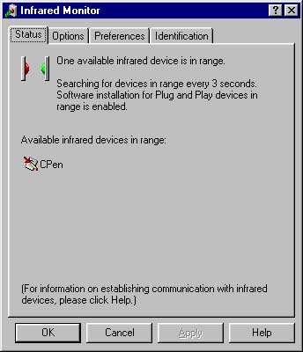
Figure 4 The Infrared Monitor for Win 9x.

The Infrared Monitor consists of four tabs, which are the Status, Options, Preference and Identification. The options in the tabs are:

The Status tab
If any devices are in range and communication is established, the device will be listed in the Status tab.

The Options tab
- Enable IR communication. If it is disabled no IR communication will be possible. If you had to enable the IR communication on a laptop, it can sometimes be necessary to restart the computer to make the port work.
- Change the COM port to which your IR adapter is physically connected. This port will be used to IR communication.
- Enter the interval in-between the Infrared Monitor’s searches for other IR devices.
- The information transmission speed can be set to the value you prefer. Please note that a slower speed can make the transmission of data more effective.

The Preference tab
- If you wish to have the Infrared icon displayed in the taskbar, it can be enabled here. Double-click the Infrared icon to display the Infrared Monitor.
- The Infrared Monitor can be set to open whenever the communication is interrupted and then disappear when connection is restored.
- A sound can be set to appear whenever the connection is interrupted. Please note that this requires a soundcard and speakers.

COM ports
In case of Windows 95 it is possible to change the COM port in the Options tab in the Infrared Monitor, Figure 5. The instructions how to find the Infrared Monitor are in the chapter The Infrared Monitor.
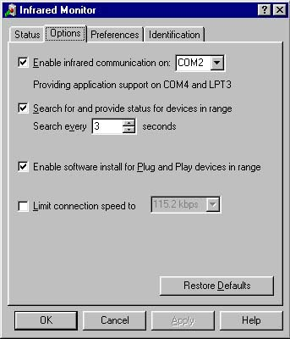
Figure 5 Options in the Win 95 Infrared Monitor.

To change the COM port in Windows 98 click the icon Network Neighborhood with the right mouse button and then select Properties. In Properties select Configuration and there you double click the Generic Infrared Serial Port or dongle, then choose Advanced. In the appearing dialog box you can now choose Serial Port to the left in Property, and COM port to the right in Value.

In Windows NT, IR drivers are not a part of the operating system and to change the COM ports the C Pen software has to be uninstalled and then re-installed. Read the chapter Uninstall and re-install IR drivers.

The C-Pen is found by the IR Monitor but connection will not establish
If there are problems with connecting to the C-Pen the error messages in Figure 6 or Figure 7 appear on the screen. Please make sure that the instructions in the chapters The C - Pen and Distance from the IR port are followed. If the problem remains, the PC’s IR software might be wrongly installed. Please check:
- Wrong IR adapter model installed? Chapter “Wrong IR adapter installed”.
- Wrong version of Wsirda.vxd? Chapter “Correct files”.
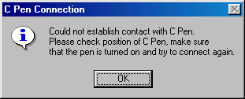
Figure 6 Error message appearing when contact could not be established.
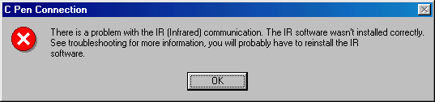
Figure 7 Wrongly installed IR software (for the C-Pen Software version 1.11 or newer).

Correct files
It is crucial to have the correct version of a few specific files otherwise you will not be able to connect to the C-Pen. The most important files are Wsirda.vxd, Infrared.dll, Infrared.inf and Infrared.cpl. Three of the files are located under C:\Windows\System and Table 1 shows the correct versions for Windows 9x. The file Infrared.inf is located in C:\Windows\inf.

File name | Version | Modified date | OS
Wsirda.vxd | 4.10.1352 | 1996-12-16 17:26 | Windows 95
Wsirda.vxd | 4.10.1998 | 1998-05-11 20:01 | Windows 98
Wsirda.vxd | - | 1999-01-26 12:12 | Windows 98 SE
Infrared.dll | 4.10.1998 | 1998-05-11 19:01 | Windows 98
Infrared.dll | 4.10.1998 | 1999-06-04 14:34 | Windows 98 SE
Infrared.inf | 4.10.1998 | 1998-05-11 19:01 | Windows 98
Infrared.inf | 4.10.1998 | 1999-01-26 12:06 | Windows 98 SE
Table 1. Versions of wsirda.vxd and infrared files in Windows 9x.

Windows 98
The original files listed in Table 1 are available on the Windows 98 CD-ROM in the cabinet files (compressed files) precopy01.cab and precopy02.cab. Use the Cabinet manager in Windows 98 if it is available. Double-click the cabinet file to the display and drag the file in order to get it copied. If the Cabinet manager is hard to find, you can always use the dos prompt.

- Open the Win98 directory in a DOS command prompt. Locate the file extract.exe.
- If you type extract you get help on extract.exe.
- For extracting infrared.dll to the system directory: extract /L c:\windows\system precopy1.cab infrared.dll.
- To extract infrared.inf to the inf directory: extract /L c:\windows\inf precopy2.cab infrared.inf.
- To extract wsirda.vxd: extract /L c:\windows\system net10.cab wsirda.vxd

In Windows 98 there are a few files, which can cause problems for the C Pen 1.0. Check if MFC42.DLL version 6.008168.0 or MSVCRT.DLL version 6.008168.0 exists in the (C:) Windows/System catalogue. If that is the case you can download an update from www.cpen.com. The update package includes version 6.00.8267.0 of MFC42.DLL and MSVCRT.DLL. If the problem remains or you are unable to access the web site, please contact your local retailer or C Technologies.

Windows NT
If the JetEye IR adapter from Exstended Systems is used and there are problems, please uninstall and reinstall with the software CD from C Technologies.

The C-Pen is not found by the Infrared Monitor
The Infrared Monitor does not find the C-Pen but the PC’s IR port is working. Check that the C Pen is working properly and if there are problems read the chapter The C - Pen. If that does not work, please contact your retailer.

Wrong IR adapter installed
If the wrong IR adapter is installed it can be changed in different ways depending on which OS you use. Make sure that you know the correct model and manufacturer! If your IR device is of another make or model number than the ones displayed during installation, please follow the manufacturer’s instruction closely. Also check that you have installed the correct COM port, chapter COM ports.

Windows 98
To check or change the type of IR device, click the right mouse button on the icon Network Neighborhood and then select Properties. Now, choose Configuration, double-click the Generic Infrared Serial Port or dongle and then select Advanced. In the appearing dialog box, you can now choose Infrared Transceiver to the left in Properties and the name to the right in Value. The available alternatives are listed in the chapter Information: IR adapters.

Windows NT
For Windows NT the IR support is included in the C-Pen Windows software. If you suspect that the wrong IR adapter was chosen during the installation the only option is to uninstall and re-install the C-Pen Windows software. Please read the chapter Uninstall and re-install.

Conflicts with other hardware
Conflicts with other hardware might be a problem. IRQ problems with PCMCIA modem or network adapters may occur. On laptops you can view the IR driver’s status by selecting Generic IR Serial Port (COM) and click on the Properties tab. The Device status should say: This device is working properly, Figure 8. The Resources tab gives the details of the problem, Figure 9.
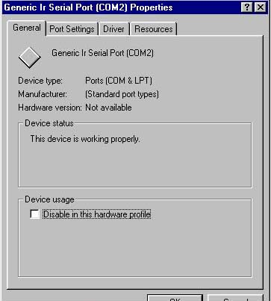
Figure 8 Generic IR Serial port, Properties
.
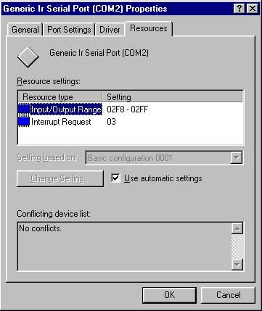
Figure 9 The details of the problem.

Interference from other equipment
Interference from other equipment can result in so called IR-alarm.

IR communication: On Notebooks (laptops)

Check the Generic IR Serial Port (COM)
On some notebooks, the IR port needs to be enabled in the BIOS setup. To see if your IR port is enabled:
- Choose Settings in the Start menu (in the lower left corner on your screen) and select the Control Panel.
- Double-click the System icon.
- In the dialog box System Properties, select the Device Manager and then the View Devices by Type.
- Double-click Ports (COM & LPT). If there is a Generic IR Serial Port (COM), your physical IR port is active, Figure 10.
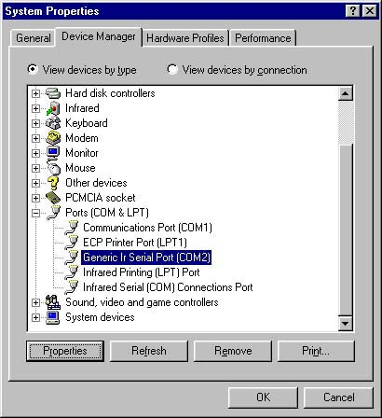
Figure 10 Check the COM ports.

Disabled Generic IR Serial Port (COM)
If there is no Generic IR Serial Port (COM), the IR port may be disabled, read the chapter Activate the IR port in BIOS Setup how to enable the infrared port.

A red cross or an exclamation mark on the Generic IR Serial Port (COM)
If the Generic IR Serial Port (COM) is marked with a red cross or an exclamation mark, the cause can be a disabled infrared port. If you do not have a physical IR port or if it is disabled, you can neither install the IR driver correctly nor start it from Windows 9x. This is what you can do:
- Check if you have a physical IR port on your computer, chapter Notebooks (laptops).
- Check if the IR driver is enabled in the Infrared Monitor, chapter Inf. Monitor/The Options tab.
- If the problem remain, the port might be disabled in the Setup. Read how to enable the IR port in the Setup, chapter Activate the IR port in BIOS Setup.

Activate the IR port in BIOS Setup
The Setup is special software from the manufacturer where you can enable or disable different devices (such as the Generic Serial Port (COM)) on your laptop, independent of Windows 95.

When you have made changes, restart the computer and check if the red cross or exclamation mark has disappeared. In order to do so, select the Control Panel in the Start menu (in the lower left corner of the screen) and then double-click System.

Unfortunately, there is no general solution to this problem, please read the laptop user guide for details or contact your laptop’s retailer. Though, an experienced PC user can on your own start the BIOS Setup according to the laptop user guide and try to solve the problem there.

Setup program available in Windows 95
On some laptops (e.g. some IBM models) the manufacturer has developed special software in order to enter the Setup directly from Windows 9x. It is not unusual that the laptop has to be restarted to show the changes in the Setup program.

Only one COM port on the laptop
If COM 1 is the only available port:
- Restart your computer.
- Reinstall the Infrared driver.
If that does not help, the IR-port may be disabled in the BIOS setup. Read the chapters Check the Generic IR Serial Port (COM and Activate the IR port in BIOS Setup to resolve the problem. If the problem remains, please contact your retailer or the Notebook manufacturer.

Error messages

Error 5
Error 5 occurs when the COM port you use is invalid. This means that your COM port is either occupied by another device or that is disabled in the bios.
To resolve this you can try to remove the COM-port that is supposed to be invalid:
- Click the Start menu (in the lower left corner of the screen), choose Settings and then Control Panel.
- Double-click the System icon and then select the Device Manager tab.
- Double-click Ports.
- Select the COM port and choose remove.
- Reboot your computer and Plug and Play will install the COM port again.

If Plug and Play does not install the port, a new port can be installed with Add New Hardware in the Control Panel. Read more about Ports in Windows help.

Error 45
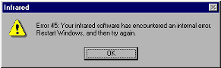
Check the infrared device’s software configuration under Network properties. If it is an external or installable device, check the connection. Then “restart Windows” appears in the Infrared Monitor. To resolve this problem:
- Click the Start menu (in the lower left corner of the screen), choose Settings and then Control Panel.
- Double-click the Infrared icon.
- In the Options tab, click the Enable infrared communications… tab
- Click the Apply button
- Repeat step 2
- Click the OK button.

If it still don’t work, remove and then reinstall the Fast Infrared Protocol.
To do so, follow these steps:

- Click Start, point to Settings, and then click Control Panel.
- Double-click Network.
- In the list of installed network components, click Fast Infrared Protocol, and then click Remove.
- Restart your computer when you are prompted to do so.
- Click Start, point to Settings, and then click Control Panel.
- Double-click Network.
- On the Configuration tab, click Add.
- Click Protocol, and then click Add.
- In the Manufactures box, click Microsoft, click Fast Infrared Protocol in the Network Protocols box, and then click OK.
- Click OK, and then restart your computer when you are prompted to do so.

MORE INFORMATION

If you install an infrared device in Windows 98, the Fast Infrared
Protocol is not installed by default. You must manually add the protocol in
Network properties.

If this does not help, restart the computer. If the computer still can not connect to the C-Pen, check if the IR Driver is correct, chapters The Infrared Monitor and Wrong IR adapter installed.
- Make sure you know the correct name of the adapter model and the manufacturer.
- Click the Start menu (in the lower left corner of the screen), choose Settings and then Control Panel. Double-click the Systems icon.
- In the Device Manager tab, select Infrared.
- Check that no Infrared Driver is marked with an exclamation mark.
- If an exclamation mark is present, remove the driver. If you have the wrong driver remove it by selecting it and pressing the delete button.
- Re-install the IR driver according to the separate installation routines in the Read me file on the C-Pen software CD.

Error 54
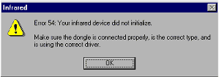
- Check that the IR adapter is correctly connected to the physical port on the backside of the computer.
- Make sure you know the correct name of the adapter model and the manufacturer.
- Click the Start menu (in the lower left corner of the screen), choose Settings and then Control Panel. Double-click the Systems icon.
- In the Device Manager tab, select Infrared.
- Check that no Infrared Driver in marked with exclamation mark.
- If an exclamation mark is present, remove the driver. If you have the wrong driver remove it by selecting it and pressing the delete button.
- Re-install the IR driver according to the separate installation routines in the Read me file on the C-Pen software CD.

No contact – Windows 9x
If the following message appears immediately after you have double-clicked My C-Pen:

- Could not establish contact with the C-Pen. Please check position of the C-Pen, make sure that the pen is turned on and try to connect again.

You may have an IR related problem in Windows 9x. Read the chapter IR communication.

No Infrared icon in the Control Panel
If you can not find the Infrared applet in the Control Panel, close the Control Panel and reopen it. You can also use the key F5 (on your keypad) to refresh the window.

Other Windows programs stop working
Faults in other windows programs can occur for the C Pen 1.01 and older versions. There can occur an inability to print due to corrupt printer dialog.

Uninstall and re-install IR drivers
The only reason to uninstall and then re-install the infrared support is if you have problems with the IR connection in Windows 98 or Windows NT. The advantages to re-install the IR driver are
- For Windows 98: The important files listed in Table 1 will be saved on your computer and there will probably be no problems with these files later on.
- For Windows NT: A wrongly installed IR driver or COM port can be uninstalled and the correct one then installed.

Windows 95
To uninstall the IR driver under Windows 95, use Start/Settings/Control Panel/Add Remove Programs. Select Infrared Support for Windows 95.

Before re-installing infrared support (Windows 95), select the Start menu (in the lower left corner of the screen), choose Control Panel and then double-click System. Select the Device Manager tab and check that there are no infrared devices. Expand ports and check that no infrared ports are listed. In case of IR ports, remove them before re-installing.

Windows 98
For Windows 98 the only option to uninstall, if necessary, is via the Device Manager. The Device Manager is found by clicking the Start menu (in the lower left corner of the screen), choose Control Panel and then double-click System. Select the Device Manager tab.

Windows NT
There is no need to uninstall the IR driver before re-installing it in Windows NT. Follow the instructions given in the dialog boxes appearing in on the screen during the re-installation. Make sure you know the IR adapters model type and manufacturer otherwise you can not install the correct driver.

Uninstall and re-install the C-Pen
In order to uninstall the C-Pen:
- Click the Start menu (in the lower left corner of the screen) and select the menu with all the C Pens functions. During installation you chose where to put the C-Pen functions and it is important to know this now.
- Select the function Uninstall C-Pen.
- If you want to uninstall the C-Pen, click yes in the following dialog box.
- The C-Pen software will automatically uninstall the C-Pen software.

If the C-Pen is to be re-installed, please read the installation routine on the C-Pen Windows Software CD.

Information: IR adapters
C Technologies support only those IR adapters listed below. But the types of IR adapters increase all the time and even if your IR adapter is not currently listed it might become supported.

There are several kinds of IR adapters, the serial infrared adapter (connected to the COM port), the motherboard adapter (very rare) and a built-in IR port. Please make sure you know your manufacturer’s name and the model.

The built-in IR port is common in Notebooks (laptops) and the configuration can vary between different models. Support from the manufacturer or retailer will probably give a customized solution.

Windows 95
Microsoft’s infrared support for Windows 95 (Infrared 2.0), with drivers for a number of IR adapter manufacturers, is included on the C-Pen software CD. If a C-Pen 1.01 (or older) is used, the Tekram IR-mate 210 is not available on the C-Pen software CD. In this case you must use the floppy disk included with the IR mate.

The supported adapters are:
- ACTiSYS 200L
- ACTiSYS 220L
- Adaptec Air 2000
- AMP PHASIR
- ESI-9680 JetEye PC
- Generic Infrared Port
- Parallax PRA9500A
- Tekram IRMate-210

Windows 98
In Windows 98, IR is a part of the operating system and is included on the Windows 98 software CD. However, it is not necessarily installed at the same time as Windows 98. If it is not installed, please read your user guide to the computer. The supported adapters are the same as for Windows 95 listed above.

Windows NT
Windows NT 4.0 has no infrared support built-in the operating system as Windows 9x. Therefore the C-Pen host computer software has support for several infrared adapters. Infrared support will be a part of Windows 2000 (the next version of Windows NT). Please read the separate installation routine in the Read me file on the C-Pen software CD, for further information about installation.

Adapters for stationary computers under Windows NT
The C-Pen software version 1.0 and 1.10 only supports the ESI-9680 JetEye PC IR (Extended Systems). The C-Pen software version 1.11 or later supports the following adapters:

- ESI-9680 JetEye PC (Extended Systems)
- Tekram IRMate-210 (Tekram technology)
- ACT-IR220L (ACTiSYS Corp.)
- CGP RSIL-200 (CGP Electronics)
- Standard Infrared Serial Port.

Built-in adapters for laptops under Windows NT
Since the C-Pen software of version 1.0 and 1.10 only supports the JetEye adapter, there is consequently no support for built-in ports in Notebooks (laptops). Version 1.12 and later has extended support on Standard Serial Port or dongle and works with several laptops. The Standard Serial Port or dongle might be useful for several kinds of laptops and we recommend you to choose it first. If it does not work, please read your laptop manual. The C-pen works properly with most types of laptops under Windows NT and these have been tested successfully:
- Compaq Armada 1575
- Dell Latitude CT
- Dell Latitude CPI
- IBM 600 Thinkpad

Information: manufacturer policy

Built-in infrared COM port
At the moment, the following COM ports are assigned in the Setup:
AST COM 2
Compaq COM 3
Dell -
Hewlett Packard COM 2 (normally)
IBM COM 2 (normally)
Siemens COM 2
Toshiba COM 2

Active or disabled IR eye as default
At the moment, the manufacturers have set IR eye is to:
AST Active
Compaq Active
Dell Active
Hewlett Packard Disabled
IBM Disabled
Siemens Active
Toshiba Active

Information: Support addresses
Mail: support@ctech.ideon.se
WWW: http://www.cpen.com

